1. **Define RPC. Describe the working of RPC**

In distributed computing, a remote procedure call is when a computer program causes a procedure to execute in a different address space.

In Distributed Computing, RPC (Remote Procedure Call) is a communication protocol that enables a client program to invoke a procedure or function in a remote server program. RPC is a fundamental concept in distributed computing, allowing clients and servers to communicate transparently over a network, as if they were running on the same machine. Here's a detailed description of how RPC works:

1. Client sends an RPC request: A client sends an RPC request to a remote server, specifying the name of the remote procedure and the arguments to be passed to it.
2. Network communication: The RPC request is transmitted over the network using a transport protocol, such as TCP/IP or UDP.
3. Server receives the request: The remote server receives the RPC request and identifies the procedure to be executed based on the procedure name.
4. Procedure execution: The server executes the remote procedure, passing the arguments provided by the client.
5. Result transmission: After the procedure is executed, the result is transmitted back to the client using the same transport protocol.
6. Client receives the result: The client receives the result of the remote procedure call and can proceed with its execution based on the outcome of the call.

RPC enables distributed applications to be developed in a modular fashion, where different components of the application can reside on different machines. By encapsulating the communication details, RPC provides a transparent and easy-to-use interface for invoking remote procedures. RPC is widely used in distributed computing, including in web services, client-server applications, and other networked systems.

{Specify “TCP/IP or UDP” in the diagram}

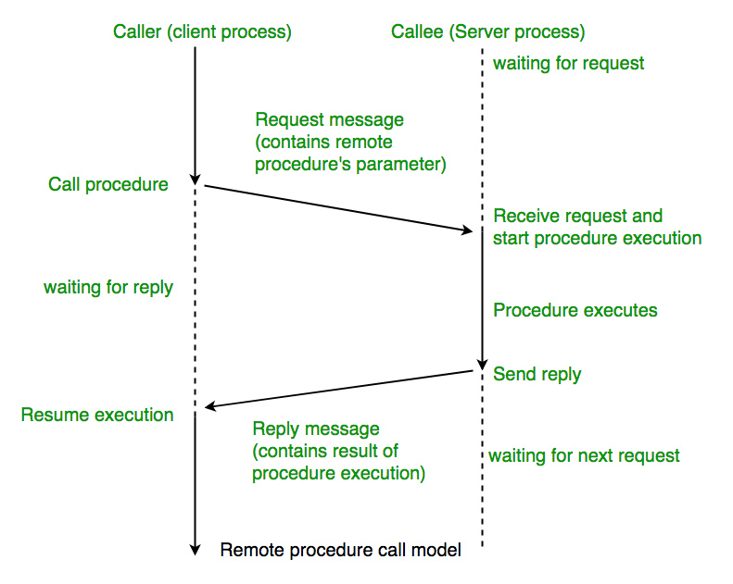

1. **Define RMI. Describe the RMI architecture/ process.**

Remote Method Invocation (RMI) is a mechanism in distributed computing that enables a client to invoke methods on objects residing on a remote server. It allows clients to interact with remote objects as if they were local objects, abstracting the complexities of network communication and object serialization.

In the RMI process, the following steps take place:

1. The client obtains a stub object from the RMI registry representing the remote object it wants to invoke.
2. The client invokes a method on the stub object as if it were a local object.
3. The stub object handles the underlying communication details. It serializes the method parameters and sends them over the network to the server.
4. The server receives the method invocation and passes it to the corresponding remote object.
5. The remote object executes the method and generates a result.
6. The result is sent back to the client through the network.
7. The stub object on the client-side receives the result, unserializes it, and returns it to the client's application.

In conclusion, RMI is a powerful mechanism in Java that simplifies the development of distributed applications. It enables seamless interaction with remote objects, hiding the complexities of network communication and object serialization. RMI promotes transparency in remote method invocation, making it easier to create robust and scalable distributed applications.

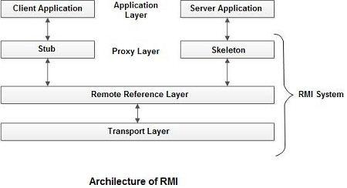

**Differentiate between message oriented and stream-oriented communication.**

| **Parameter** | **Message-Oriented Communication** | **Stream-Oriented Communication** |
| --- | --- | --- |
| Type of data | Message-based | Stream-based |
| Transmission method | Send and receive messages | Continuous data flow |
| Data unit | Message | Stream of bytes |
| Message boundaries | Clear boundaries between messages | No clear message boundaries |
| Suitability for data size | Suitable for small amounts of data | Suitable for large amounts of data |
| Overhead | Higher overhead due to message headers | Lower overhead without message headers |
| Synchronization | Blocking and non-blocking options | Only blocking option available |
| Reliability | Higher reliability with message acknowledgments | Lower reliability as lost data may not be detected |
| Examples | Email, instant messaging | Video streaming, file transfer |

1. Explain group communication with its types:

Broadcast Communication, Multicast Communication, Unicast Communication

Group communication refers to the exchange of information between multiple processes or entities simultaneously. It is a critical aspect of distributed computing, allowing for efficient communication and coordination between different nodes or components of a system. The following are the three types of group communication:

1. Broadcast Communication: In broadcast communication, a process sends the same message to all the other processes in the group. This type of communication is useful for tasks such as system updates, where the same information needs to be propagated to all the nodes in the system.
2. Multicast Communication: Multicast communication allows a process to send a message to a subset of the processes in the group. The processes that receive the message are defined by a multicast address, which is a group identifier that is shared by all the members of the group. This type of communication is useful for tasks such as group messaging or collaborative applications.
3. Unicast Communication: Unicast communication is a point-to-point communication between two processes. It is the most basic form of communication in distributed computing and involves a sender process sending a message to a receiver process. While unicast communication is not a group communication per se, it is an essential building block for many distributed systems.

Group communication can be implemented using various protocols and technologies such as IP multicast, middleware like JMS, or socket-based programming. By leveraging group communication, distributed systems can achieve better scalability, fault tolerance, and performance, making it a critical aspect of modern distributed computing.

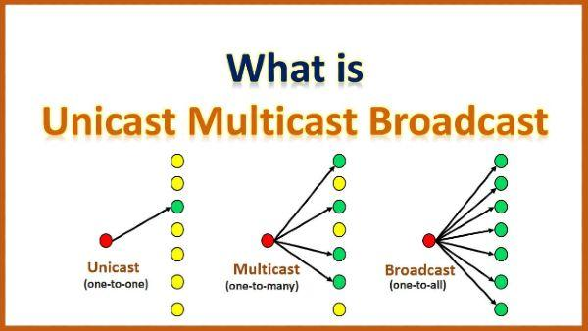

1. **Explain centralized algorithm with example for mutual exclusion in DS. [10M]**

Centralized algorithm for mutual exclusion in distributed systems:

1. Nodes send access requests to a central coordinator.
2. The coordinator checks if the shared resource is available.
3. If available, the coordinator grants access to a requesting node and notifies others of resource occupancy.
4. The node accesses the resource and releases it when done.
5. The coordinator updates resource availability and notifies all nodes.

Example: In a distributed system with multiple nodes, a shared printer is connected to a coordinator. Nodes requesting printer access send requests to the coordinator. If the printer is available, the coordinator grants access, and the requesting node can use the printer exclusively. Once finished, the node releases the printer, and the coordinator updates its availability for other nodes. Note: Centralized algorithm ensures mutual exclusion but can become a bottleneck in large systems due to all requests going through the coordinator.

1. **What is mutual exclusion? Requirements and Performance measure of Mutual exclusion Algorithms.**

Mutual exclusion ensures that only one process accesses a shared resource at a time in distributed systems. Requirements for mutual exclusion algorithms:

1. Safety: Only one process can access the critical section at any time.
2. Liveness: Processes waiting to access the critical section eventually gain access.
3. Fairness: The order of granting access should be fair, avoiding continuous blocking of processes.

Performance measures for mutual exclusion algorithms:

1. Mutual exclusion delay: Time a process waits before entering the critical section.
2. System throughput: Number of processes entering the critical section per unit time.
3. System overhead: Cost incurred by the system to maintain mutual exclusion. Different algorithms like centralized, distributed, and token-based are used based on system requirements.
4. **What is token and non-token-based algorithm in mutual exclusion?**

In distributed systems, mutual exclusion is a mechanism used to ensure that only one process at a time can access a shared resource. There are two types of mutual exclusion algorithms: token-based and non-token-based.

1. Token-Based Algorithm(Centralized): In this algorithm, a token is passed between processes to control access to a shared resource. The token represents permission to access the resource, and a process can only access the resource when it holds the token. When a process is finished accessing the resource, it passes the token to the next process in a predefined order.
2. Non-Token-Based Algorithm (Distributed): In this algorithm, no token is used to control access to the shared resource. Instead, each process requests permission to access the resource and must wait until it is granted access before accessing the resource. When a process is finished accessing the resource, it releases it, and another process can request access.

Both token-based and non-token-based algorithms have their advantages and disadvantages, and the choice of algorithm depends on the specific requirements of the distributed system. For example, token-based algorithms are more efficient in systems where processes have a well-defined order, while non-token-based algorithms are more flexible in systems where processes do not have a predefined order.

1. **Explain the performance analysis of different Mutual exclusion algorithms.**  
   Performance analysis of different mutual exclusion algorithms in distributed systems:
2. Message Complexity: Number of messages exchanged during execution. Lower complexity reduces network traffic and delays.
3. Time Complexity: Amount of time taken for algorithm execution. Lower complexity improves process waiting time and system throughput.
4. Scalability: Ability to handle a large number of processes. Algorithm should scale efficiently without compromising performance.
5. Fairness: Providing equal opportunity for process access to critical section. Ensures no process is indefinitely blocked.
6. Starvation Freedom: Prevention of processes being indefinitely prevented from entering critical section. Every process eventually enters.
7. Overhead: Additional processing required by the algorithm. Lower overhead improves system performance.
8. Number of Critical Sections: Efficient handling of multiple critical sections in the application.

A good mutual exclusion algorithm should have low message and time complexity, scalability, fairness, starvation freedom, low overhead, and efficient handling of multiple critical sections. These factors collectively contribute to the overall performance and effectiveness of the algorithm in distributed systems.

Skipped Topics:

Explain Ricart Agrawalas algorithm for mutual exclusion in DS.[10M]

Explain suzuki kasamis broadcast algorithm for mutual exclusion in DS.[10M]

Explain Raymond tree based algorithm for mutual exclusion in DS.[10M]

Explain Singhals Heuristics algorithm for mutual exclusion in DS.[10M]

* 1. **State the desirable features of global scheduling algorithms.**

Global scheduling algorithms are an essential component of operating systems that allocate resources such as **CPU time, memory, and input/output devices** among different processes. Desirable features of global scheduling algorithms are:

1. Fairness: Ensuring all processes receive a fair share of resources, avoiding starvation.
2. Throughput: Maximizing the number of completed processes per unit of time for optimal system throughput.
3. Response time: Minimizing the time taken for a process to start execution after entering the system for optimal response time.
4. Predictability: Providing consistent and stable performance over time for predictable behaviour.
5. Efficiency: Scheduling processes quickly with minimal delays or overhead for efficient resource utilization.
6. Load balancing: Balancing the workload across available resources to prevent resource underutilization or overload.
7. Priority: Supporting priority levels to give preference to high-priority processes.
8. Pre-emption: Allowing interruption of process execution for higher-priority processes or time quantum enforcement.
9. Robustness: Handling unexpected events or system failures without major disruptions or failures.
10. Scalability: Efficiently handling large numbers of tasks or processes without compromising performance. Global scheduling algorithms incorporate these features to allocate resources effectively, maintain fairness, optimize system performance, and ensure a smooth and efficient operation of the operating system.

In summary, global scheduling algorithms aim to ensure that resources are allocated fairly and efficiently, and that the system's performance is optimal.

* 1. **Explain Task Assignment approach.**

The Task Assignment approach in distributed computing involves allocating tasks to nodes in a distributed system for efficient resource utilization. Here are the key points to consider:

1. Allocation of tasks: A central controller assigns tasks to nodes based on capabilities and available resources.
2. Static task assignment: Workload is divided in advance among nodes and remains fixed throughout the computation. Suitable for known workload and simple computations.
3. Dynamic task assignment: Tasks are dynamically allocated based on factors like workload, resource availability, and performance. Ideal for complex computations with a changing workload.
4. Algorithms for task assignment:
5. Round-robin assigns tasks in a circular order, ensuring equal workload distribution.
6. Random assignment assigns tasks randomly.
7. Load balancing algorithms: Tasks are allocated based on workload and node performance, optimizing task distribution.

In conclusion, the Task Assignment approach in distributed computing optimizes resource utilization, load balancing, and fault tolerance. The choice between static and dynamic assignment, as well as the selection of appropriate task assignment algorithms, depend on the nature of the computation, workload, and available resources.

* 1. **Explain Load Balancing Approach.**

Load balancing is a crucial approach in distributed computing that aims to distribute the workload evenly across nodes for optimal resource utilization. Here's a concise and improved pointwise answer:

1. Static Load Balancing: a. Deterministic Load Balancing: Tasks are assigned to nodes in a fixed manner based on predefined criteria. Suitable for predictable workloads but may not adapt well to changes in workload or varying resources. b. Probabilistic Load Balancing: Tasks are assigned to nodes randomly based on predefined criteria. Useful for uncertain workloads or varying resources, but can lead to imbalanced workloads.
2. Dynamic Load Balancing: a. Centralized Load Balancing: A central controller assigns tasks to nodes based on workload and node performance. Suitable for small-scale systems with low workloads, but scalability and single point of failure are concerns. b. Distributed Load Balancing: i. Cooperative Load Balancing: Nodes collaborate to distribute workload evenly. Ideal for systems with high workloads and many nodes, but coordination and communication overheads exist. ii. Non-Cooperative Load Balancing: Nodes compete for workload based on performance and resource availability. Suitable for small-scale systems with low workloads, but imbalances and decreased system performance can occur.

In conclusion, load balancing ensures optimal resource utilization and system performance in distributed computing. The choice of load balancing approach depends on the workload characteristics and available resources.

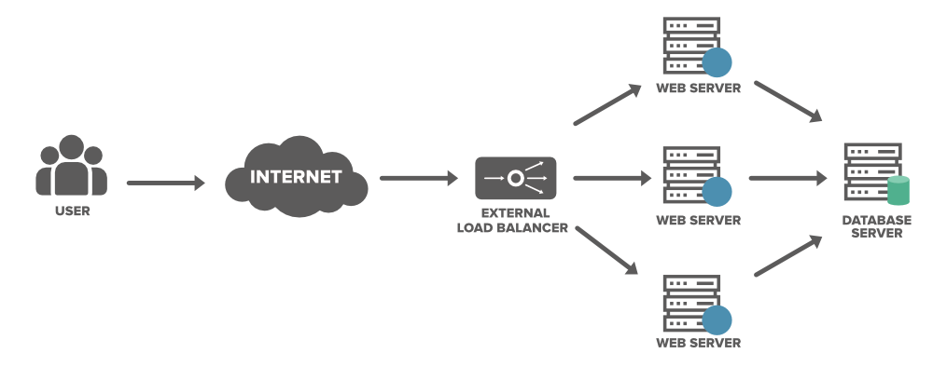

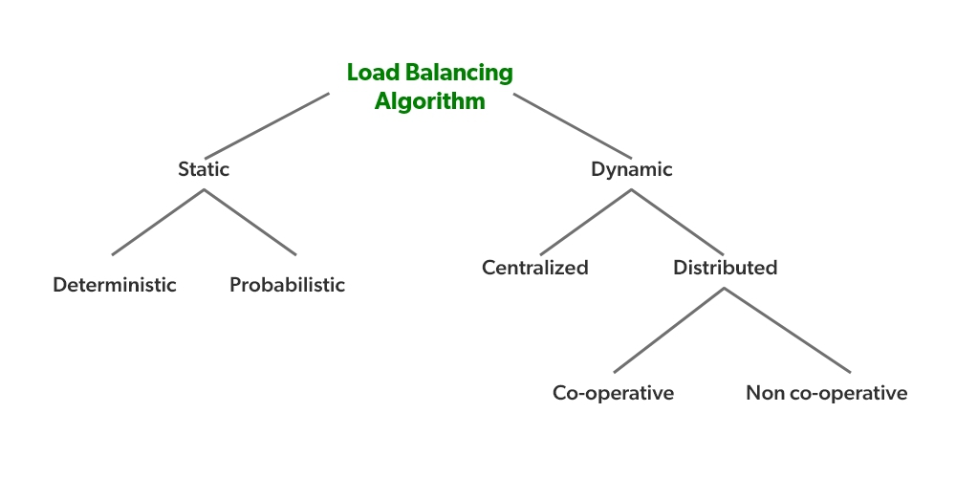

* **What is process migration. What are the issues in process migration.**

Process migration is a technique used in distributed computing to move an active process from one node to another node in a network. This technique allows for better resource utilization and load balancing in a distributed system. However, there are several issues that need to be addressed to ensure successful process migration:

1. Data transfer: The process's data needs to be transferred from the source node to the destination node, which can be time-consuming and resource-intensive.
2. Network latency: The process migration process can be delayed due to network latency, which can affect the performance of the system.
3. Process synchronization: The process needs to be synchronized between the source and destination nodes to ensure that there are no inconsistencies in the process's state.
4. Process interruption: The process migration process can cause interruption to the process, which can lead to data loss or incorrect results.
5. Security: The migration process needs to be secure to prevent unauthorized access to the process's data.

Addressing these issues is important to ensure successful process migration and optimize the performance of the distributed system.

1. **Differentiate between process and threads.**

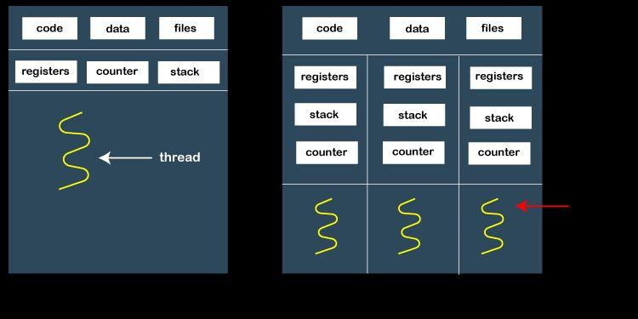

| **Parameter** | **Process** | **Thread** |
| --- | --- | --- |
| Definition | An instance of a program in execution | A lightweight unit of execution within a process |
| Resource allocation | Each process has its own resources such as memory, file descriptors, etc. | Threads within a process share the same resources as the parent process |
| Communication | Inter-process communication (IPC) is required for processes to communicate with each other | Threads can communicate directly with each other through shared memory or message passing |
| Creation | A new process is created through forking | A new thread is created within a process using the thread library |
| Context Switching | Switching between processes is more expensive, as it requires saving and restoring the entire process context | Context switching between threads is less expensive, as it requires saving and restoring only the thread-specific context |
| Parallelism | Processes are heavy-weight and better suited for tasks that require a lot of resources | Threads are light-weight and better suited for tasks that require less resources and need to be executed in parallel |
| Fault tolerance | If a process crashes, it does not affect other processes in the system | If a thread crashes, it may affect other threads within the same process |
| Security | Processes provide better security as each process runs in its own address space and cannot access the memory of other processes | Threads share the same address space as the parent process and can access the same memory, making it more difficult to ensure security |

In summary, processes and threads differ in their resource allocation, communication, creation, context switching, parallelism, fault tolerance, and security. Understanding these differences can help in choosing the appropriate approach for implementing concurrent programming in distributed computing systems.

* **Multi-threading models. Differentiate between User leveland Kernel Level thread**

| **Parameter** | **User-Level Threads** | **Kernel-Level Threads** |
| --- | --- | --- |
| Managed by | User-level thread library (user space) | Kernel (system) |
| Thread creation | Faster, as the thread creation is done in user space. | Slower, as the creation of threads involves system calls. |
| Context switching | Faster, as it is done in user space without kernel intervention. | Slower, as it involves kernel intervention. |
| Scheduling | User-level threads are scheduled by thread library, which relies on kernel-level threads for execution. | Kernel-level threads are scheduled by the kernel itself. |
| Visibility to kernel | Not visible to the kernel, the kernel only sees a single thread of execution per process. | Visible to the kernel, which can schedule them on different processors and manage them as individual entities. |
| Blocking system calls | A single blocking system call can block all threads in the process. | One thread blocking doesn't affect other threads in the process. |
| Scalability | Limited scalability as scheduling is dependent on kernel-level threads. | More scalable, as each thread can be scheduled individually by the kernel. |
| Fault tolerance | If a user-level thread blocks, the entire process is blocked. | Kernel-level threads are more fault-tolerant as they can be managed individually by the kernel. |
| Resource sharing | User-level threads share the same resources within a process. | Kernel-level threads can share resources across different processes. |

1. **Virtualization. Explain the role of virtualization in distributed computing**.

Virtualization is crucial in distributed computing as it allows for the creation of multiple virtual machines on a single physical machine, providing the following benefits:

1. Better resource utilization: Virtualization maximizes hardware resource usage by running multiple virtual machines on a single physical server. This reduces the need for additional hardware, leading to cost savings and improved efficiency.
2. Enhanced isolation and security: Each virtual machine operate independently, isolated from others. If one virtual machine experiences a failure or security breach, it does not impact the others, ensuring better security and maintaining the availability of applications.
3. Simplified management: Virtual machines are managed individually without affecting others. Administrators can perform maintenance tasks, install updates, and troubleshoot issues on specific virtual machines, simplifying management processes.
4. Increased flexibility: Virtualization allows for easy migration of virtual machines between physical servers. In case of a server failure, virtual machines can be quickly transferred to alternate servers, minimizing downtime and ensuring continuity of operations.
5. Enablement of cloud computing: Virtualization is a fundamental technology in cloud computing. Cloud providers utilize virtualization to create and manage virtual machines, allowing customers to run their applications and services on remote servers, enabling scalability and flexibility.

In summary, virtualization in distributed computing optimizes resource utilization, provides isolation and security, simplifies management tasks, offers flexibility through migration, and forms the foundation for cloud computing services.

1. **Code Migration. Write short note on Code Migration**

Code migration is the process of transferring a program or a part of it from one system to another in distributed computing. It enables resource sharing, load balancing, and fault tolerance. Here's a concise pointwise explanation:

1. Definition: Code migration involves moving code or executable files in a distributed system.
2. Benefits: It enables resource sharing, load balancing, and fault tolerance.
3. Types: a. Static migration: Code transferred at the start of execution.
   * Deterministic migration: Code transferred to a predetermined location.
   * Probabilistic migration: Code transferred based on probability.

b. Dynamic migration: Code transferred during execution.

* + Centralized migration: Code destination determined by a central controller.
  + Distributed migration: Code destination determined by multiple nodes.
    - Cooperative migration: Nodes collaborate to determine destination.
    - Non-cooperative migration: Nodes compete to determine destination.

1. Purpose: Facilitates resource sharing, load balancing, and fault tolerance.

In summary, code migration plays a crucial role in distributed computing by enabling resource sharing, load balancing, and fault tolerance.

1. **Differentiate. Compare load sharing , Load Balancing, Task assignment.**

| **Parameter** | **Load Sharing** | **Load Balancing** | **Task Assignment** |
| --- | --- | --- | --- |
| Definition | Technique to distribute workload among multiple devices | Technique to distribute workload evenly across multiple devices | Technique to assign tasks to available resources based on their capabilities |
| Objective | To maximize resource utilization and minimize overload | To minimize response time and maximize throughput | To allocate tasks to available resources for efficient execution |
| Approach | Devices share workload by handling incoming requests in a coordinated manner | Workload is distributed based on device's capability and workload demand | Tasks are assigned to resources based on their capability and workload requirement |
| Granularity | Coarse-grained workload distribution, each device takes on a specific task | Fine-grained workload distribution, tasks are broken down into smaller units and distributed | Fine-grained task distribution, individual tasks are assigned to specific resources |
| Load Distribution | Devices take on a portion of the overall workload | Workload is distributed across devices based on their capability and workload demand | Tasks are distributed based on the capability and workload requirement of resources |
| Resource Utilization | May result in underutilization of resources due to static workload distribution | Attempts to balance workload across devices to maximize resource utilization | Ensures efficient resource utilization by matching task requirements with resource capabilities |
| Failure Tolerance | Can handle device failures by reassigning workload to other devices | Can handle device failures by redistributing workload to other devices | Can handle device failures by reassigning tasks to other available resources |
| Examples | DNS servers, file servers | Load balancers, cluster managers | Task schedulers, job managers |

1. **Explain different load estimation policies and process transfer policies used by load balancing algorithm.**

Load Estimation Policies:

1. Round-Robin: Assign workload equally to each node in a sequential manner.
2. Weighted Round-Robin: Assign workload based on node capacity or performance.
3. Exponential Smoothing: Predict workload using historical data with a smoothing effect.
4. Moving Average: Calculate average workload over a specific time window for current estimation.

Process Transfer Policies:

1. Random Transfer: Transfer processes randomly to any available node.
2. Centralized Transfer: A central controller determines the best node based on workload and resources.
3. Threshold-Based Transfer: Transfer processes when specific thresholds (e.g., CPU utilization) are exceeded.
4. Dynamic Transfer: Transfer processes based on real-time monitoring of workload and performance.

These simplified points provide a quick overview of the different load estimation and process transfer policies used in load balancing algorithms.

1. **Discuss various issues in designing Load Balancing algorithms.**
2. Scalability: Ensuring the load balancing algorithm can handle a large number of nodes and increasing workload without performance degradation.
3. Overhead: Minimizing the additional computational and communication overhead introduced by the load balancing algorithm.
4. Load Estimation Accuracy: Developing accurate methods to estimate the workload on each node for effective load balancing.
5. Adaptability: Designing algorithms that can dynamically adjust to changes in the system, such as node failures or workload fluctuations.
6. Fault Tolerance: Incorporating mechanisms to handle node failures and redistribute workload to maintain system reliability.
7. Network Topology Awareness: Considering the network topology to make informed load balancing decisions and minimize communication delays.
8. Energy Efficiency: Designing load balancing algorithms that aim to minimize energy consumption in distributed systems.
9. Load Balancing Overhead: Ensuring that the load balancing process itself does not consume excessive resources or introduce delays.
10. Cost-Effectiveness: Balancing the benefits of load balancing against the cost of implementing and maintaining the load balancing algorithm.
11. What is replication? Write the advantages of replication. Explain replication as scaling technique in distributed computing.

In distributed computing, replication refers to the practice of creating multiple copies of data or computation tasks across different nodes in a network. This is done to increase the reliability, availability, fault tolerance, and performance of the system. Replication can be seen as a scaling technique that can be used to improve the performance and scalability of distributed systems. By creating multiple copies of data or tasks across different nodes in the network, the workload can be distributed across the nodes, reducing the workload on any one node and improving the overall performance of the system.

Advantages of replication in distributed computing include:

1. Improved Performance: Replication reduces access latency and improves response times by placing data closer to users.
2. Increased Availability: Replication ensures data and services are accessible even if some replicas fail.
3. Scalability: Replication enables handling increasing user demands by distributing workload across multiple replicas.
4. Load Balancing: Replication prevents overloading of a single replica by distributing the workload.
5. Fault Tolerance: Replication provides backup copies that can take over in case of failures or errors.
6. Localized Data Access: Replication allows users to access data quickly from nearby replicas, reducing network traffic.
7. Reduced Network Congestion: Replication minimizes data transfer over the network, reducing congestion and improving efficiency.
8. Enhanced Data Consistency: Replication ensures all replicas have consistent and up-to-date data through synchronization mechanisms.
9. Geographical Distribution: Replication allows for data and services to be replicated across different locations, providing localized access and reducing network impact.
10. Disaster Recovery: Replication enables data recovery and system restoration in the event of disasters or accidents by maintaining copies in separate locations.
11. Explain different failure models.
12. Crash Failure: A node abruptly stops and becomes unresponsive, resulting in the loss of all data and state.
13. Omission Failure: A node fails to send or receive messages, causing communication issues and potential data loss.
14. Byzantine Failure: A node behaves maliciously by sending incorrect or misleading information to other nodes, leading to inconsistent or incorrect results.
15. Partition Failure: The network is divided into multiple disconnected partitions, preventing communication between nodes in different partitions.
16. Performance Failure: A node's performance degrades significantly, causing delays or timeouts in message processing.
17. Timing Failure: A node's timing behavior deviates from the expected behavior, leading to synchronization problems and coordination issues.
18. Transient Failure: A failure that occurs temporarily and resolves on its own, causing disruptions but not permanent damage.
19. Network Failure: The underlying network infrastructure fails, resulting in communication failures between nodes.
20. Software Failure: Errors or bugs in the software running on a node cause it to malfunction or crash.
21. Power Failure: The power source supplying a node is interrupted, causing an immediate shutdown and loss of data.
22. Explain Byzantine Agreement Problem with example.

**LEASIE LAMPORT IS THE INVENTOR**

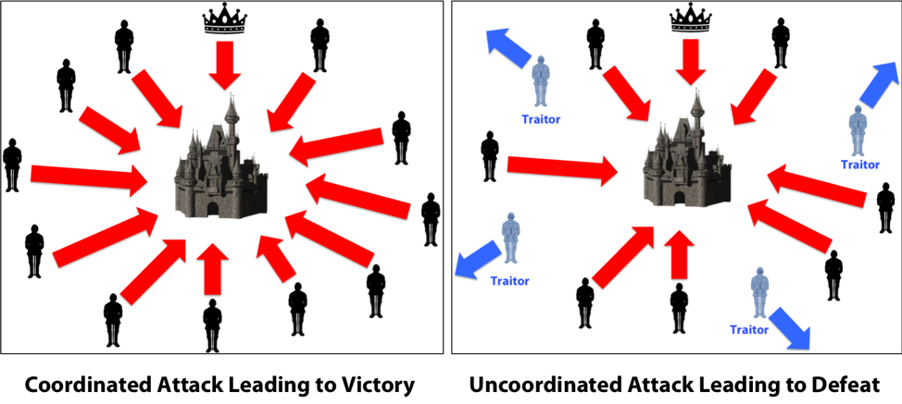

1. The Byzantine Agreement Problem is a theoretical challenge in computer science that involves achieving consensus (agreement) among a group of entities.
2. The problem is named after the hypothetical scenario called the Byzantine Generals' Problem.
3. In the scenario, a group of Byzantine generals surrounds a city and needs to agree on a coordinated attack plan.
4. Some of the generals may be traitors who can send conflicting or false messages to disrupt the agreement process.
5. The loyal generals aim to reach a consensus despite the presence of these traitors.
6. The challenge is to design algorithms or protocols that enable the loyal generals to agree on a plan and disregard the conflicting messages from traitors.
7. This problem is relevant in distributed systems, blockchain technology, and other scenarios where consensus among multiple parties is crucial.
8. Solving the Byzantine Agreement Problem requires addressing potential failures or malicious behavior.
9. Various algorithms and protocols, such as **Byzantine Fault Tolerance (BFT)** algorithms, have been developed to tackle this problem.
10. However, achieving Byzantine agreement remains a complex challenge in computer science.

By understanding and addressing the Byzantine Agreement Problem, researchers aim to devise reliable and secure consensus mechanisms for distributed systems.

1. **Explain different types of failure that can occur in RPC and suggest their solutions.**
2. Communication failure: Occurs when the client and server cannot establish a connection or lose connectivity during RPC.
   * Solution: Implement mechanisms such as timeout and retry to handle communication failures.
3. Data corruption: Data transferred during RPC gets corrupted due to transmission errors.
   * Solution: Employ error detection and correction techniques like checksums or cyclic redundancy checks (CRC) to detect and recover from data corruption.
4. Server overload: The server becomes overwhelmed with too many requests, leading to performance degradation or failure to respond.
   * Solution: Implement load balancing techniques to distribute client requests across multiple servers and prevent overload.
5. Security vulnerabilities: Unauthorized access, data breaches, or malicious attacks compromise the security of RPC communications.
   * Solution: Implement secure communication protocols like SSL/TLS, authenticate clients and servers, and employ encryption to protect RPC communication.
6. Versioning mismatch: Incompatible versions of the client and server result in RPC failures.
   * Solution: Implement version negotiation mechanisms to handle versioning mismatches and ensure compatibility between client and server.
7. Resource limitations: Insufficient resources on the client or server side can lead to RPC failures or degraded performance.
   * Solution: Monitor resource usage, optimize resource allocation, and scale the infrastructure to handle increased demand.
8. **Explain different types of ordering of the messages in group communication.**
9. FIFO Ordering: Messages are delivered in the order they were sent by the sender.
10. Causal Ordering: Messages are delivered in the order that respects causality, meaning messages that depend on each other are delivered in the correct order.
11. Total Ordering: Messages are delivered in a global order agreed upon by all processes, regardless of the order in which they were sent.
12. Lamport Timestamps: Messages are assigned Lamport timestamps to establish a partial ordering based on the sending and receiving events.
13. Agreement Ordering: Messages are delivered only when all members of a group have agreed upon the order in which they should be delivered.
14. Uniform Total Ordering: Messages are delivered to all processes in the same order, preserving total ordering across the entire group.
15. Atomic Delivery: Messages are delivered to all group members simultaneously, ensuring that they all see the same set of messages at the same time.
16. **What is checkpointing? Explain Independent and Coordinated checkpointing approaches.**

Sure! Here's a concise and focused answer for the question:

Checkpointing is a technique used in distributed systems to capture the state of a process at a specific moment. There are two main approaches to checkpointing: independent and coordinated.

1. Independent checkpointing: Each process takes its checkpoint independently without coordination with other processes. This approach allows processes to save their states locally without the need for coordination. It is simpler to implement but may result in inconsistent checkpoints if processes take checkpoints at different times.
2. Coordinated checkpointing: In this approach, processes coordinate and synchronize their checkpoints to ensure consistency across the system. Coordination algorithms are used to determine when all processes have reached a checkpoint. Coordinated checkpointing ensures consistency but introduces coordination overhead and may impact system performance.

Both independent and coordinated checkpointing aim to provide fault tolerance and enable recovery in distributed systems. The choice between the two approaches depends on the system's requirements and the trade-offs between simplicity and consistency.

Overall, checkpointing plays a crucial role in ensuring the reliability and fault tolerance of distributed systems by capturing process states and enabling recovery when failures occur.

1. **What is message logging? What are the advantages of message logging.**

Message logging is the process of recording messages that are sent and received by processes in a distributed system. It involves storing a copy of each message sent or received by a process, along with a timestamp, in a persistent storage such as a file or a database. Message logging is an essential technique for fault tolerance and recovery in distributed systems, as it enables the system to recover from failures by replaying the logged messages.

1. Reliable delivery: Message logging ensures messages are reliably delivered, even during failures.
2. Fault tolerance: Message logging enables systems to recover and replay messages after failures, avoiding data loss.
3. System debugging: Message logs help developers trace and analyze system issues by examining the sequence and content of logged messages.
4. Audit and compliance: Message logging provides a record of system communication for auditing and regulatory compliance.
5. Replication and synchronization: Message logs support replication and synchronization by allowing replicas to replay messages for consistent state across nodes.

Message logging is a fundamental technique in distributed systems that offers benefits such as reliable message delivery, fault tolerance, system debugging and analysis, audit and compliance, as well as supporting replication and synchronization.

1. **Explain recovery-oriented computing.**
2. Recovery-oriented computing is a way of designing and building distributed computing systems that can recover from failures.
3. It involves making sure that even if one or more parts of the system fail, the system can continue to work properly and provide uninterrupted service to users.
4. One way to do this is by replicating data or system components, so if one part fails, there is a backup to take its place.
5. Recovery mechanisms like checkpointing, rollback, and forward recovery are also used to restore a system to a working state after a failure.
6. Checkpointing involves regularly saving the state of the system, so it can be restored to a previous state if a failure occurs. Rollback and forward recovery are other methods that can be used to recover from failures.
7. Coordinating the recovery of all parts of the system is also important to make sure everything is restored together. This can be difficult in large systems, so sometimes an uncoordinated approach is used where each part recovers independently.

Overall, recovery-oriented computing is important in distributed computing because failures are more likely to happen due to the complexity of the system. By designing systems with recovery mechanisms and coordinating recovery efforts, we can make sure the system remains reliable and works properly even when failures occur.

1. What is Distributed Shared Memory. What are the design issues in the DSM.

Distributed Shared Memory (DSM) is a programming concept that enables multiple processes in a distributed system to access a shared memory space. It provides a familiar programming model similar to programming on a single machine, where processes can read from and write to the shared memory. However, since the memory is spread across different nodes, ensuring data consistency becomes a challenge. DSM systems use consistency models to manage the order and visibility of memory updates. DSM simplifies distributed programming by abstracting the complexities of message passing and explicit data sharing, making it easier for developers to write distributed applications.

Design Issues:

1. Consistency Model: DSM systems need to define a consistency model that determines the ordering and visibility of memory updates across distributed nodes.
2. Coherency Protocol: A coherency protocol is required to ensure that all copies of shared data in the distributed system are kept consistent.
3. Memory Access Latency: The latency of accessing remote memory in a distributed system can be higher compared to local memory access, impacting performance.
4. Scalability: DSM systems must be designed to scale efficiently as the number of nodes or processes accessing the shared memory increases.
5. Fault Tolerance: Ensuring fault tolerance in a DSM system is crucial, as failures in nodes or network connections can affect the availability and consistency of shared memory.
6. Differentiate

| **Parameter** | **Data-Centric Consistency Model** | **Client-Centric Consistency Model** |
| --- | --- | --- |
| View of data | Global view | Local view |
| Synchronization mechanism | Centralized | Decentralized |
| Data access mechanism | Shared memory or distributed data structure | Remote procedure call or message passing |
| Consistency model | Strong consistency | Eventual consistency |
| Concurrency control | Locking, optimistic, or transactional | Timestamp ordering or conflict resolution |
| Network traffic | High | Low |
| Application suitability | Complex and critical systems | Simple and non-critical systems |
| Trade-off between consistency and performance | Strong consistency can cause high latency and reduced availability | Eventual consistency can provide high availability but may result in data divergence |
| Examples of systems | Banking, stock exchange | Social media, search engines |

summary of Data Centric Consistency Models

<https://www.geeksforgeeks.org/consistency-model-in-distributed-system/>

1. **What is stable storage? How it plays role in recovery of DS.**

Stable storage is crucial for distributed systems, offering reliability and resilience in the face of failures. It ensures that data remains available and recoverable, even in the event of crashes or network partitions. Implementing stable storage involves replication, where data is duplicated across multiple storage devices, or using fault-tolerant file systems that replicate data across multiple disks. By leveraging stable storage, lost data can be recovered, ensuring system consistency and returning it to a reliable state. Overall, stable storage is a critical component in distributed systems, providing a dependable mechanism to store and recover data, contributing to the overall resilience and consistency of the system.

1. In Distributed Computing, Write a note on Consistency

Consistency is an important aspect of distributed systems that ensures that all the replicas of a shared object in a distributed system see the same value at the same time. In other words, consistency ensures that the shared data in a distributed system is always up to date and accurate.

There are several types of consistency models used in distributed systems to ensure that shared data is consistent across all the replicas. These include:

1. Strong Consistency: In this model, all replicas of the data are guaranteed to have the same value at all times. Any read operation will always return the most recent value of the data.
2. Sequential Consistency: This model ensures that the order in which the updates to the shared data occurred is preserved across all the replicas. Any read operation will return the value of the most recent update or an older value that occurred before the most recent update.
3. Causal Consistency: In this model, the ordering of events that led to the updates of the shared data is preserved across all the replicas. Any read operation will return the value of the most recent update or an older value that occurred before the most recent update.
4. Eventual Consistency: This model allows replicas to have different values of the data temporarily but guarantees that eventually, all replicas will converge to the same value.
5. Weak Consistency: This model allows replicas to have different values of the data at any given time. Any read operation may return different values at different replicas.
6. Read Your Writes: This model guarantees that any read operation performed after a write operation will always return the updated value of the data.
7. Write Follows Reads: In this model, a write operation is only allowed after a read operation is performed. This ensures that the write operation is based on the most recent value of the data.

In summary, consistency is critical in distributed systems to ensure that shared data is accurate and up to date across all replicas. Different consistency models can be employed to achieve various levels of consistency depending on the requirements of the distributed system.

| **Category** | **Strict Consistency** | **Sequential Consistency** | **Causal Consistency** | **Weak Consistency** | **Release Consistency** | **FIFO consistency** |
| --- | --- | --- | --- | --- | --- | --- |
| Definition | All processes observe the same order of events at the same time. | All processes observe a total order of events, but may observe events at different times. | Events are causally related are observed in the same order by all processes, but concurrent events can be observed in different orders. | No guarantee on the order of concurrent events observed by different processes. | Updates to shared data are made visible in a coordinated way by the system. | Similar to sequential consistency, but preserves the order of writes by each process. |
| Usage | Used in applications that require strong consistency guarantees, such as banking systems. | Used in applications where a total order of events is required, such as in database transactions. | Used in applications where causality is important, such as in distributed simulations. | Used in applications where performance is important and consistency can be traded off, such as in distributed caching systems. | Used in applications where multiple versions of shared data need to be maintained and coordinated, such as in versioned file systems. | Used in applications where ordering of writes by each process is important, such as in collaborative editing systems. |
| Advantages | Provides strong consistency guarantees and a single global view of the system state. | Provides a total order of events without requiring synchronization of all processes. | Supports causality, which can be important in some applications. | Provides high scalability and availability by allowing inconsistency in the system. | Allows multiple versions of shared data to be maintained and coordinated. | Preserves the order of writes by each process, which can be important in collaborative applications. |
| Disadvantages | Requires synchronization of all processes, which can limit scalability and performance. | May have higher overhead than weaker consistency models due to the need for synchronization. | May require complex causal ordering protocols, which can be difficult to implement. | May sacrifice consistency for performance, which may not be suitable for all applications. | Requires more coordination and communication between processes. | May have higher overhead due to the need to maintain order of writes by each process. |

1. **What are the desirable features of a good distributed file systems? What is file sharing semantics. Explain various file sharing semantics.** .

A distributed file system is a type of file system that allows multiple users and applications to access and share files over a network. It is an essential component of distributed computing as it enables users to store and share data across a network of computers. The following are some of the desirable features of a good distributed file system:

1. Scalability: A good distributed file system should be able to scale to accommodate a large number of users and files. It should be able to handle an increasing amount of data over time.
2. Reliability: The system should be reliable and should not suffer from data loss or corruption. It should be able to recover from failures and ensure data consistency.
3. Security: The system should be secure and should provide access control mechanisms to prevent unauthorized access to data.
4. Performance: The system should be designed to provide high-performance access to files.
5. Transparency: The system should be transparent to the users, meaning that they should be able to access and share files without being aware of the underlying system architecture.

File sharing semantics are the rules and conventions that determine how files are accessed and shared in a distributed file system. How multiple users or applications can access and modify files in a distributed file system. It defines how different users or applications can access, modify, and share files stored in the distributed file system.

There are different types of files sharing semantics, including Unix, Session, Immutable, and Shared File Semantics:

1. Unix File Sharing Semantics: Unix file sharing semantics are based on the Unix file system model. In this model, files are represented by inodes, which contain information about the file, such as its permissions and ownership. Multiple users can access the same file simultaneously, and changes made by one user are immediately visible to other users.
2. Session File Sharing Semantics: Session file sharing semantics are used in systems where a user or application is expected to access a file for an extended period of time. In this model, the file is locked by the user or application, and other users are prevented from accessing it until the lock is released.
3. Immutable File Sharing Semantics: Immutable file sharing semantics are used in systems where files are not expected to change once they are created. In this model, the file is read-only, and users cannot modify or delete it.

In conclusion, a good distributed file system should have desirable features such as scalability, reliability, security, performance, and transparency. The file sharing semantics used in a distributed file system determine how files are accessed and shared and include Unix, Session, Immutable, and Shared File Semantics.

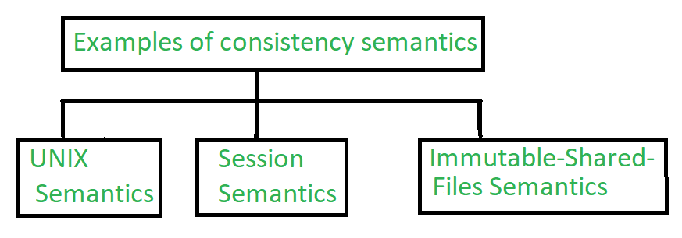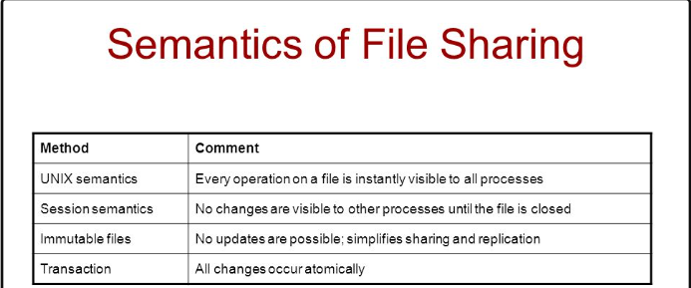

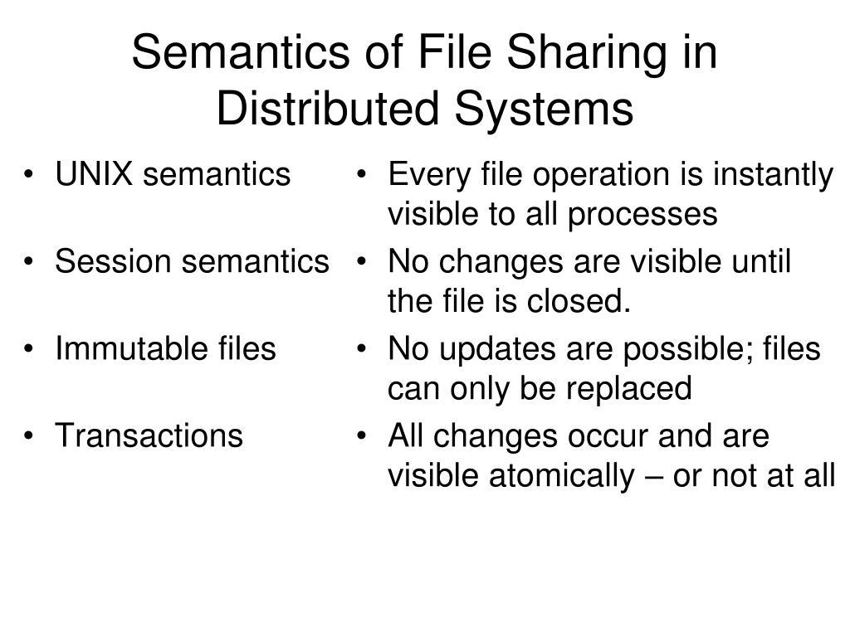

<https://www.geeksforgeeks.org/consistency-semantics-for-file-sharing/>

1. **Explain file accessing models: Remote service model, Data caching model.**

File accessing models in distributed systems can be categorized based on the unit of data access/transfer and the method utilized for accessing remote files.

Based on the unit of data access/transfer

there are four models:

1. File level transfer model: Entire files are transferred over the network as a unit, and clients access files by specifying their name and location, resolved using a centralized naming service or directory.
2. Block level transfer model: The file is divided into fixed-size blocks, and each block is stored on a separate server. Clients access the blocks directly, rather than the file as a whole. This model is used in distributed file systems where files are too large to be transferred efficiently over the network.
3. Byte level transfer model: Data is transferred as individual bytes, rather than as a whole file or block. This model is often used for streaming media applications, where data is transferred in real-time over the network.
4. Record level transfer model: Data is transferred as individual records, which can be thought of as logical units of data with a fixed structure. This model is often used for databases and other structured data storage systems.

Based on the method utilized for accessing remote files, there are two models:

1. Remote service model: Files are stored on a remote server, and clients can access them over a network connection using a standardized protocol such as NFS or SMB. This model is often used in enterprise environments where multiple users need to access the same files, or in cloud-based environments where users access files stored on remote servers.
2. Data caching model: Frequently accessed files are stored in a local cache to reduce the need for network access. Caching can be done at various levels, such as at the operating system or application level. This model is often used in distributed systems where clients access files stored on remote servers to reduce network traffic and improve performance.
3. **Explain File Caching Schemes.**

In distributed computing, file caching schemes are used to enhance performance by reducing network accesses and decreasing latency. Caching schemes involve storing frequently accessed files in a local cache, which helps satisfy subsequent requests without requiring network access. There are several file caching schemes that can be used in distributed computing, which are as follows:

* Client caching: This scheme involves caching files on the client's local disk. Whenever a client needs to access a file, it first checks if a local copy of the file is available. If the file is present, it is directly accessed from the cache. This scheme is simple to implement but may not be effective in environments where clients are frequently updated or where multiple clients access the same file.
* Server caching: In this scheme, files are cached on the server's local disk. Whenever a client requests a file, the server first checks if a local copy of the file is available in the cache. If the file is present, it is directly served from the cache. This scheme is effective in reducing network traffic but can lead to cache consistency issues if multiple clients access the same file.
* Proxy caching: This scheme involves caching files on a proxy server located between the client and the server. Whenever a client requests a file, the request is first directed to the proxy server. The proxy server then checks if a local copy of the file is available in the cache. If the file is present, it is directly served from the cache. This scheme is effective in reducing network traffic and improving performance, but it requires an additional infrastructure layer and may lead to cache consistency issues.
* Distributed caching: This scheme involves caching files on multiple servers distributed across the network. Whenever a client requests a file, the request is first directed to the nearest server. The server then checks if a local copy of the file is available in the cache. If the file is present, it is directly served from the cache. This scheme is effective in reducing network traffic and improving performance, but it requires a complex infrastructure and may lead to cache consistency issues.

1. **Explain different techniques to transfer data between client and server.**

In distributed computing, data transfer between client and server is a crucial aspect of communication. The efficient transfer of data can improve performance and reduce network traffic. There are several techniques for data transfer between client and server, which are as follows:

1. Message Passing: In this technique, data is transferred between client and server using messages. The client sends a message to the server, and the server responds with a message. Message passing can be done using different communication protocols such as TCP, UDP, and HTTP. This technique is widely used in distributed systems, as it allows for efficient communication between different nodes.
2. Remote Procedure Calls (RPC): In this technique, the client invokes a procedure or method on the server, which performs some computation and returns the result to the client. The procedure or method can be written in any programming language and executed on the server. RPCs can be implemented using different communication protocols such as RPC over TCP or RPC over HTTP.
3. Representational State Transfer (REST): In this technique, data is transferred between client and server using HTTP requests. The client sends a request to the server, which performs some computation and returns a response in a predefined format such as JSON or XML. REST APIs are widely used in web applications, as they allow for easy integration with different programming languages and platforms.
4. Publish-Subscribe: In this technique, the client subscribes to a particular topic or event, and the server publishes data related to that topic or event. The server broadcasts the data to all subscribers, and the client receives the data. This technique is commonly used in distributed systems for real-time data processing, such as stock market updates or social media feeds.
5. File Transfer: In this technique, the client requests a file from the server, and the server transfers the file to the client. File transfer can be done using different protocols such as FTP or SFTP. This technique is useful for transferring large files between client and server.

Overall, the choice of data transfer technique depends on the application requirements and the characteristics of the distributed system. A combination of these techniques can be used to achieve efficient and reliable data transfer between client and server.

1. Explain: Andrew File Systems AFS.

Andrew File System (AFS) is a distributed file system that allows users to access files stored on remote servers as if they were stored on their local machine. It was developed at Carnegie Mellon University in the 1980s and has been widely used in academic and research institutions. Here is an overview of AFS:

1. Architecture: AFS uses a client-server architecture, where clients access files stored on remote servers. The servers are organized into a hierarchy of cells, with each cell containing a set of servers and a local database of file metadata.
2. Security: AFS provides strong security features, including authentication, access control, and encryption. Users are authenticated using Kerberos, and access to files is controlled using Access Control Lists (ACLs).
3. Caching: AFS uses a sophisticated caching mechanism to improve performance. Files that are frequently accessed are cached on the client's local disk, so that subsequent accesses can be satisfied without requiring network access. AFS also uses a callback mechanism to ensure that cached copies are up-to-date.
4. Replication: AFS supports file replication, which allows files to be stored on multiple servers for improved availability and fault tolerance. When a file is modified on one server, the changes are automatically propagated to other servers that store replicas of the file.
5. Scalability: AFS is designed to scale to large numbers of users and files. The hierarchical organization of cells allows for easy management of large distributed systems, and the caching and replication mechanisms help to reduce network traffic and improve performance.
6. Open source: AFS has been released as open source software under the Apache License, which allows for continued development and improvement of the system by the community.
7. Explain: Network File Systems NFS.

Network File System (NFS) is a distributed file system that allows users to access files over a network as if they were stored on their own local machine. NFS allows multiple clients to access files stored on a remote server in a transparent manner, making it easy to share files and resources between computers in a network. Here are some key points to understand about NFS:

1. Architecture: NFS is based on a client-server model, where a server exports its file system and a client mounts it as a local file system. The client can then access the files on the server as if they were stored locally.
2. Protocols: NFS uses two main protocols - the Remote Procedure Call (RPC) protocol for communication between the client and server, and the Network Lock Manager (NLM) protocol for file locking and synchronization.
3. File Access: NFS allows clients to read, write, and execute files stored on the server, as well as create, delete, and rename files and directories. The files can be accessed using standard file system commands like ls, cd, cp, mv, etc.
4. Security: NFS provides authentication and access control mechanisms to ensure that only authorized clients can access the files on the server. However, NFS has been criticized for its security vulnerabilities and is generally not recommended for use over untrusted networks.
5. Performance: NFS performance can be affected by factors such as network latency, bandwidth, and server load. To improve performance, NFS uses caching and buffering techniques to reduce the number of network accesses and improve data transfer rates.

Overall, NFS is a popular and widely used distributed file system that provides a convenient and transparent way to share files and resources in a networked environment.

1. Explain: Google File Systems GFS.

Google File System (GFS) is a distributed file system that was developed by Google to meet its large-scale data storage needs. It was designed to handle the massive amounts of data generated by Google's search engine, which at the time of its development was the most popular search engine on the internet. GFS is widely used within Google, and has influenced the development of other distributed file systems, such as Hadoop Distributed File System (HDFS). Here are some key features and characteristics of GFS:

1. Scalability: GFS is designed to be highly scalable, and can handle petabytes of data across thousands of commodity servers. This makes it well-suited for applications that generate large amounts of data, such as web search and machine learning.
2. Fault-tolerance: GFS is designed to be fault-tolerant, which means that it can continue to function even if some of its components fail. To achieve this, GFS uses a master-slave architecture, where a single master node manages multiple slave nodes. If a slave node fails, the master node can redirect its requests to other nodes.
3. Data partitioning: GFS partitions data into fixed-size chunks, typically 64 megabytes in size. These chunks are distributed across multiple servers, which allows for parallel processing of data. GFS also uses a distributed metadata system to manage file and chunk metadata, which allows for efficient scaling of the file system.
4. Write-once-read-many (WORM) model: GFS is designed to handle large files that are written once and read many times, such as log files and web pages. This model allows for high-performance reads, as data is stored in a contiguous block and can be read sequentially.
5. High throughput: GFS is optimized for high-throughput data access, which means that it can handle large amounts of data being read or written simultaneously. This makes it well-suited for applications that require fast data processing, such as data analytics and machine learning.

In summary, GFS is a highly scalable and fault-tolerant distributed file system designed to handle large amounts of data across thousands of commodity servers. It is optimized for high-throughput data access and is well-suited for applications that generate and process large amounts of data.

1. Explain X.500 Directory Service.

X.500 Directory Service is a standard protocol for managing distributed directories, also known as directory services. It was designed to provide a global directory service that can be accessed by various applications and services over a network. Here is a simplified explanation of X.500 Directory Service:

1. Directory structure: X.500 defines a hierarchical directory structure, similar to a file system structure, where information is stored in a tree-like structure with nodes called Directory Information Trees (DIT). Each node in the tree represents an object, such as a person, organization, or service.
2. Naming convention: X.500 uses a naming convention called the Distinguished Name (DN) to uniquely identify each object in the directory. The DN is a sequence of relative distinguished names (RDN) that starts at the root of the directory tree and identifies the object's position in the tree.
3. Directory access: X.500 defines a set of protocols, such as Directory Access Protocol (DAP) and Lightweight Directory Access Protocol (LDAP), to access and manipulate the directory data. DAP is a full-featured protocol that allows complex operations, while LDAP is a simpler protocol designed for lightweight directory access.
4. Directory replication: X.500 allows directory data to be replicated across multiple servers to provide fault tolerance and improve performance. Each server maintains a copy of the directory data, and updates are propagated across the servers to ensure consistency.
5. Security: X.500 provides several security features, such as authentication, access control, and encryption, to ensure that directory data is secure and protected from unauthorized access.

Overall, X.500 Directory Service is a powerful and flexible protocol for managing distributed directories, with features such as a hierarchical structure, naming convention, directory access protocols, replication, and security.

1. Explain Hadoop Distributed File System HDFS..

Hadoop is a distributed system designed to process and store large volumes of data across multiple computers. It is an open-source framework that provides a scalable and reliable platform for distributed storage and distributed processing of big data.

At its core, Hadoop consists of two main components: the Hadoop Distributed File System (HDFS) and the MapReduce programming model.

1. Hadoop Distributed File System (HDFS): HDFS is a distributed file system that allows data to be stored and accessed across multiple machines in a Hadoop cluster. It is designed to handle large data sets and provides fault tolerance and high throughput. HDFS breaks down data into blocks and replicates them across multiple machines to ensure data availability and reliability. It enables data-intensive applications to read and write data in parallel, making it suitable for big data processing.
2. MapReduce Programming Model: MapReduce is a programming model used for processing and analyzing large data sets in a parallel and distributed manner. It simplifies the development of distributed applications by dividing the processing tasks into two stages: map and reduce. The map stage processes input data and produces intermediate results, while the reduce stage aggregates the intermediate results to generate the final output. MapReduce automatically handles the distribution of tasks across the nodes in a Hadoop cluster, providing scalability and fault tolerance.

Overall, Hadoop is a distributed system that enables the processing and storage of big data across multiple machines, offering scalability, fault tolerance, and the ability to handle large volumes of data. It has become a popular choice for organizations dealing with big data analytics and processing tasks.

1. Explain the File Replication in distributed computing

File replication is a common technique used in distributed computing to ensure that data is available and accessible at all times. It involves creating multiple copies of the same file and storing them in different locations across the network. This is done to increase the availability and reliability of data, as well as to improve performance and reduce network traffic.

Here are some key points to keep in mind when explaining file replication in distributed computing:

1. Redundancy: File replication provides redundancy by creating multiple copies of the same file in different locations. This ensures that if one copy of the file becomes unavailable, there are other copies that can be accessed instead.
2. High Availability: By replicating files across multiple machines, data is always available and accessible. If one machine fails, another copy of the file is available to ensure continuous access.
3. Load Balancing: File replication can also be used for load balancing, distributing data and processing tasks across multiple machines to improve performance.
4. Consistency: File replication also involves ensuring consistency across all the copies of the file. When a file is updated, all the copies of the file are updated to ensure that all users have access to the latest version of the file.
5. Synchronization: To ensure consistency across all copies of the file, synchronization is necessary. Synchronization ensures that all copies of the file are updated at the same time, preventing data inconsistencies and ensuring that all users have access to the latest version of the file.

Overall, file replication is an important technique used in distributed computing to ensure high availability, reliability, and performance of data. It involves creating multiple copies of the same file and distributing them across different machines, ensuring that data is always available and accessible to users.

1. Write a note on Global name service in distributed computing

Global name service in distributed computing is a way to manage and locate resources in a distributed system. It is a system that provides a naming convention that is globally unique, so that resources can be located across different networks and domains. It allows users to refer to resources by a single name, regardless of where they are physically located.

There are several benefits of using a global name service in distributed computing, including:

* It simplifies resource management by providing a consistent naming convention.
* It enables transparent access to resources, regardless of their location.
* It supports load balancing and fault tolerance by allowing resources to be replicated across different locations.
* It facilitates the integration of different systems and networks by providing a standardized naming convention.

One example of a global name service in distributed computing is the Domain Name System (DNS), which maps domain names to IP addresses on the internet. DNS allows users to access websites and services using a human-readable domain name, rather than a hard-to-remember IP address.

Overall, global name service is an important aspect of distributed computing, as it enables resources to be managed and located across different networks and domains. It provides a consistent naming convention, transparent access to resources, and supports load balancing and fault tolerance.